Mapuche Silver

One of the most recognizable symbols of Chilean indigenous culture is that of the Mapuche woman clad in full regalia and covered in stunning silver adornments. Mapuche silversmithing may not be an ancient tradition, but it is one that has come to define the modern perception of handcrafts in Chile. Mapuche silver jewelry can be found in almost any market throughout Chile and serves to lure in tourists as well as locals alike into the magical cosmology of Chile’s indigenous population.

Who are the Mapuche?
Translated as ‘People of the Earth’, the Mapuche are Chile’s largest indigenous group. Divided into various sub-groups they inhabited a wide range of geographic environments, from the Andes Mountains that divide Chile and Argentina, down to the coast between Aconcagua River and Chiloé Island. As their name suggests their culture is one in connection with nature. The rich Mapuche cosmology is inspired by natural landscapes and represented in everyday objects such as ceramics, textiles and jewellery.

History of Mapuche Silvercraft
One of the most prized crafts among the Mapuche is silversmithing. This craft began as late as the latter half of the 18th century when the 1726 Parliament of Negrete allowed for increased trade of silver between colonial Chile and the independent Mapuches. Furthermore, the Mapuche retrafes or silversmiths, who originally employed more simplistic techniques of hammering, cutting, burnishing, and perforating, had learned more complex methods from the Spaniards which in turn led to more intricate designs.
The most prolific use of silver was for jewellery. Distinctive designs were meant to represent different reynma (families), lof mapu (lands) as well as specific lonkos (chiefs) and machis (shamans). The jewellery was typically worn as a combination of pieces such as trarilonko (a chain link belt), chaway and upul (earrings), trapelakucha (chest adornment), akucha (breast pins), and tupu (shawl clasps). Typical Mapuche jewellery incorporates geometric shapes and is composed of square, rectangular, trapezoidal, or rounded silver plates, often joined by links. These shapes signify esoteric connections with the land and the gods. Some pieces also feature birds, insects, humans and ophidians. 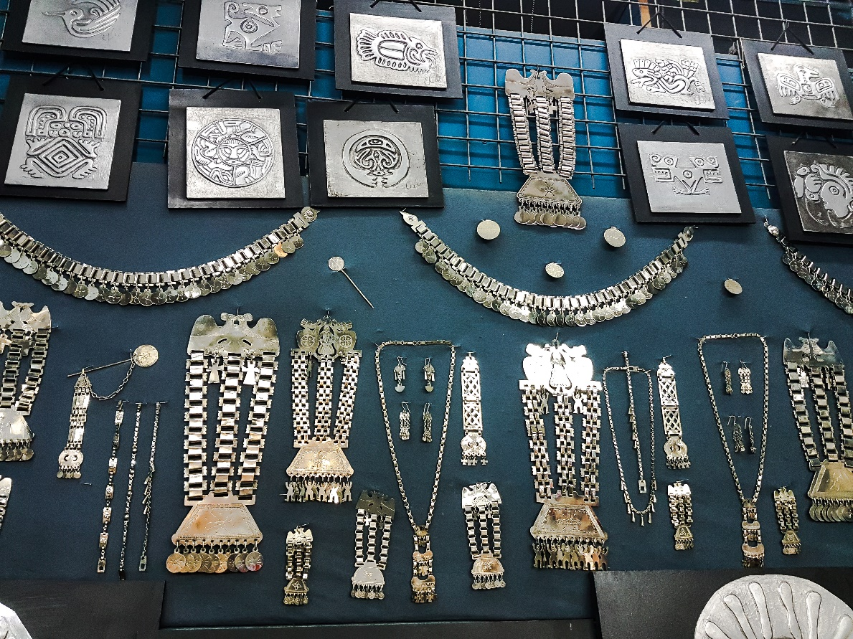
For Mapuche women silver jewellery had powerful religious connotations and was believed to protect them from evil spirits. The head and chest were most heavily adorned as they were deemed to be the most vital body parts and hence in most need of protection. Silver jewellery was worn on important occasions such as ceremonies, rituals, festivals, celebrations of the harvest and even when undertaking important journeys into the city. Due to its believed powers of repelling evil the jewellery was also worn when receiving or engaging with untrustworthy strangers who may carry malintent.

Rise and fall
Machupe silversmithing reached its zenith in the 19th century displaying incredible artistic diversity and high quality workmanship. At its peak, every important Mapuche chief employed at least one silversmith. Unfortunately, in the 20th century the tradition had been all but abandoned. This can be attributed to several factors. First, the Mapuche have a custom of melting down old pieces to make new ones or of selling off the jewellery in exchange for food and other commodities. Secondly, the Mapuche had lost their lands in the early 20th century, leaving many impoverished or exiled. Finally, the supply of silver was significantly reduced and no longer used in Chilean coinage.
Nowadays, the retrafes, Mapuche traditional silversmiths, have gone almost completely out of existence. Sadly, truly authentic Mapuche silver jewellery now only survives in museums or private collections.

Commodifying the tradition
If all the Mapuche silversmiths have disappeared then how is it that Chilean markets are filled with Mapuche silver jewellery? The answer is simple: this jewellery is either manufactured by modern methods to be sold to tourists, or it is handmade in a traditional fashion, but not by the traditional retrafes, Mapuche silversmiths.
While the modern shopper must be diligent and discerning in their selection of a Mapuche jewellery piece to purchase, it is arguably still a worthwhile purchase and a great way to honor the memory of Mapuche traditions. Many modern high-quality jewellery makers are of Mapuche lineage striving to make creations that honor their cultural past.
When shopping for the perfect piece of Mapuche-style jewellery one must first be wary of the material as many earrings on sale in markets are not silver but alpaca, a metal allow that has a silvery appearance, but is made up of cooper, nickel and zinc, with no trace of silver. A great way to spot these is by their low price. Another caveat is whether the jewellery was made by hand or machine. Handmade jewellery will usually have imperfect shapes or specific individual qualities, while the machine made ones will have a perfectly shaped form and a uniform appearance. When asked, the sellers are generally honest about the origin and creation of the pieces on offer.
Nearly all markets in Chile sell some form of Mapuche-style jewellery. The tourist based markets will most likely sell the mass produced type, while small boutiques specializing in silver are more likely to carry handmade items. There are countless silversmiths who incorporate Mapuche-style jewellery into their collections.

Where to buy in Santiago:
- Santa Lucia Market - Feria Artesanal Santa Lucia
Location: Avenida Liber Bernardo O'higgins S/N & Carmen, Santiago, Región Metropolitana
Located at the foot of the Santa Lucia Hill and just steps away from Santa Lucia Metro Station (Red Line), this market offers typical souvenirs catering to the tourist market. The prices here are usually lower but one must beware of the quality of the products on offer. Nevertheless, there are several shops with authentic handmade products.
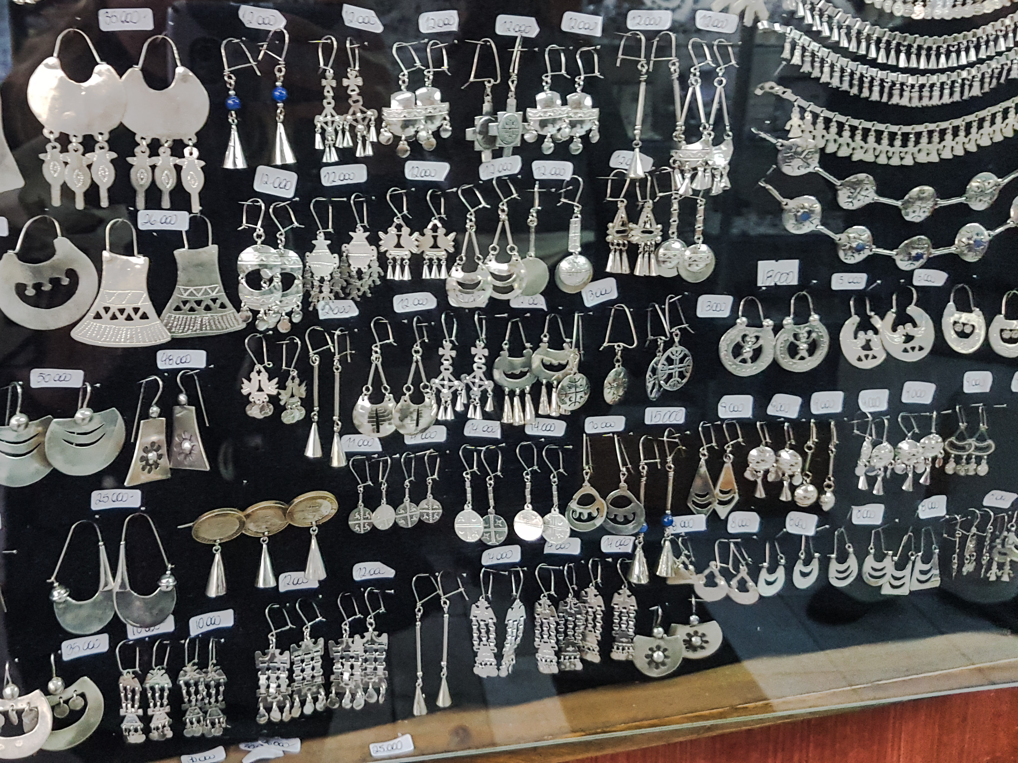
- Patio Bellavista
Location: Pío Nono 73, Providencia, Santiago, Chile
This market is part of a modern dining and shopping complex. Here one can find small boutiques, once again catering to tourists but of a higher design quality. It is a ten minute walk from Baquedano Metro station (Red or Green Line) and just across the bridge from Plaza Italia. When crossing the bridge and just before Patio Bellavista there is another small bohemian open-air market that offers handcrafted items, although usually not of particularly high quality.
- Los Dominicos Handcraft Village - El Centro Artesanal Pueblito Los Dominicos
Location: Apoquindo 9085, Las Condes, Región Metropolitana
Situated with the breathtaking background of the Andes Mountains this market is built in the form of a traditional village. It is five minute walk from Los Dominicos Metro Station (Red Line terminal stop) and just behind the stunning Iglesia Los Dominicos. This market has over 200 small artisan shops where the artists can be seen working during the day to produce high quality original and traditional products.

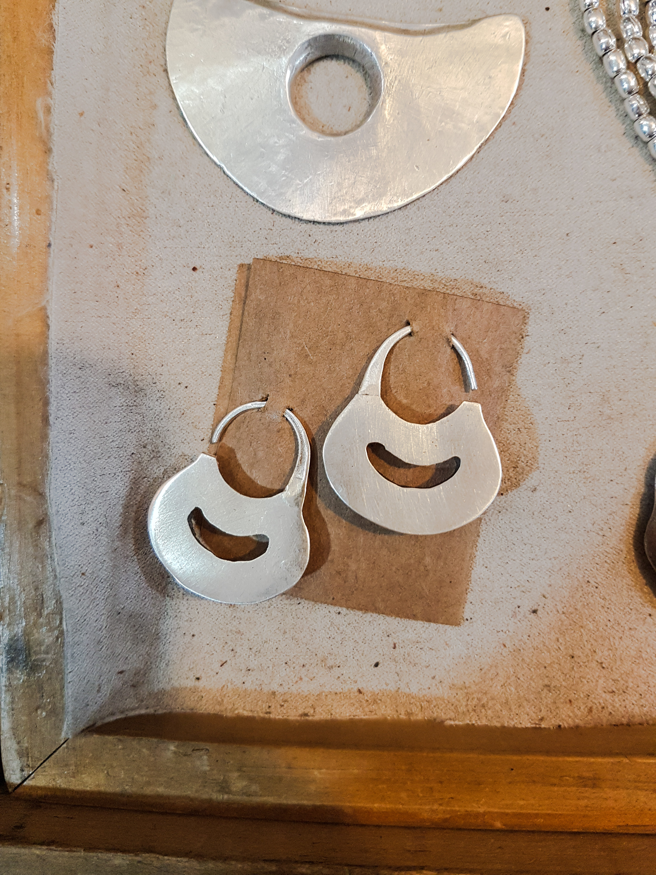
- Lágrimas de Luna (Moon Tears)
Location: B 3110, Nueva Costanera, Vitacura, Región Metropolitana
Online shop: http://lagrimasdeluna.com
A luxury fair trade silver jewellery boutique featuring indigenous Mapuche designs inspired by nature and handcrafted using traditional techniques in Chile. The higher prices are reflective of the quality and attention to detail. This boutique is focused on the jewellery admirer who prefers good quality long lasting pieces verses the tourist market. Their work has been featured in several fashion magazines.

